**Karan Arora**  **R.L. Institute M: 9416974837**

**Topic: Solution**

**Time: 1 hr COMPETITIVE TEST** **M.M. 25 x 4 = 100**

1. An open beaker of water in equilibrium with water vapour is in a sealed container. When a few grams of glucose are added to the beaker of water, the rate at which water molecules :

|  |  |
| --- | --- |
| a) Leaves the vapour increases | b) Leaves the solution increases |
| c) Leaves the solution decreases | d) Leaves the vapour decreases |

1. A graph of vapour pressure and temperature for three different liquids X , Y and Z is shown below :

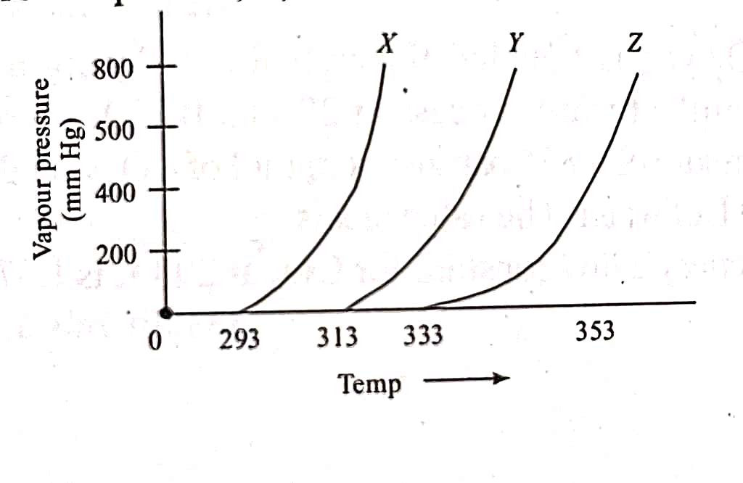

The following inferences are made :

(A) X has higher intermolecular interactions compared to Y.

(B) X has lower intermolecular interactions compared to Y.

(C) Z has lower intermolecular interactions compared to Y.

|  |  |  |  |
| --- | --- | --- | --- |
| a) (A) & (C) | b) (A) | c) (B) | d) (C) |

1. The vapour pressure of pure liquids A and B are 400 and 600 mm Hg respectively at 298 K. On mixing the liquids the sum of their initial volumes is equal to the volume of the final mixture. The mole fraction of liquid B in the mixture is 0.5. The vapour pressure of the final solution, the mole fraction of the components A and B in vapour phase, respectively are :

|  |  |  |  |
| --- | --- | --- | --- |
| a) 450 mm Hg ; 0.4 ; 0.6 | b) 500 mm Hg ; 0.5 ; 0.5 | c) 450 mm Hg ; 0.5 ; 0.5 | d) 500 mm Hg ; 0.4 ; 0.6 |

1. The solubility of N2 in water at 300 K and 500 torr partial pressure is 0.01 g/L. The solubility (in g/L) at 750 torr partial pressure is :

|  |  |  |  |
| --- | --- | --- | --- |
| a) 0.0075 | b) 0.005 | c) 0.02 | d) 0.015 |

1. The molarity of a solution obtained by mixing 750 mL of 0.5 M HCl with 250 mL of 2 M HCl will be :

|  |  |  |  |
| --- | --- | --- | --- |
| a) 0.875 M | b) 1 M | c) 1.75 M | d) 0.975 M |

1. K2HgI4 is 40% ionized in aqueous solution. The value of its van’t Hoff factor is :

|  |  |  |  |
| --- | --- | --- | --- |
| a) 1.6 | b) 1.8 | c) 2 | d) 2.2 |

1. Elevation in the boiling point for 1 molal solution of glucose is 2 K. The depression in the freezing point for 2 molal solution of glucose in the same solvent is 2 K. The relation between Kb and Kf is :

|  |  |  |  |
| --- | --- | --- | --- |
| a) Kb = 1.5 Kf | b) Kb = Kf | c) Kb = 0.5 Kf | d) Kb = 2 Kf |

1. 18 g glucose is added to 178.2 g of water. The vapour pressure of water (in torr) for this aqueous solution is :

|  |  |  |  |
| --- | --- | --- | --- |
| a) 752.4 | b) 759 | c) 7.6 | d) 76 |

1. The observed osmotic pressure for a 0.1 M solution of Fe(NH4)2(SO4)2 at 25 is 10.8 atm. The expected and experimental (observed) value of van’t Hoff factor will be respectively.

|  |  |  |  |
| --- | --- | --- | --- |
| a) 5 and 4.42 | b) 4 and 4.00 | c) 5 and 3.42 | d) 3 and 5.42 |

1. The freezing point (in $℃$) of a solution containing 0.1 g of K3 [Fe(CN)6] (Mol. wt. 329) in 100 g of water is :

|  |  |  |  |
| --- | --- | --- | --- |
| a) – 2.3 x 10 – 2 | b) – 5.7 x 10 – 2 | c) – 5.7 x 10 – 3 | d) – 1.2 x 10 – 2 |

1. During depression of freezing point in a solution, the following are in equilibrium :

|  |  |
| --- | --- |
| a) Liquid solvent , solid solvent | b) Liquid solvent , solid solute |
| c) Liquid solute , solid solute | d) Liquid solute , solid solvent |

1. The freezing point of equimolal aqueous solutions will be highest for :

|  |  |  |  |
| --- | --- | --- | --- |
| a) C6H5NH3Cl | b) Ca (NO3)2 | c) La (NO3)3 | d) C6H12O6 |

1. A 0.002 m aqueous solution of an ionic compound Co(NH3)5 (NO2)Cl freezes at – 0.00732 $℃$. Number of moles of ions which 1 mole of ionic compound produces on being dissolved in water will be :

|  |  |  |  |
| --- | --- | --- | --- |
| a) 2 | b) 3 | c) 4 | d) 1 |

1. A solution of containing 10 g per dm3 of urea is isotonic with a 5 % solution of a non-volatile solute. The molecular mass of the solute is :

|  |  |  |  |
| --- | --- | --- | --- |
| a) 250 g/mol | b) 300 g/mol | c) 350 g/mol | d) 200 g/mol |

1. If 0.15 g of solute, dissolved in 15 g of solvent, is boiled at a temperature higher by 0.216 $℃$, than that of the pure solvent , the molecular weight of the substance is (molal elevation constant for solvent = 2.16 $℃$).

|  |  |  |  |
| --- | --- | --- | --- |
| a) 1.01 | b) 10 | c) 10.1 | d) 100 |

1. At 25 $℃$, the highest osmotic pressure is exhibited by 0.1 M solution of :

|  |  |  |  |
| --- | --- | --- | --- |
| a) CaCl­2 | b) KCl | c) glucose | d) urea |

1. Find out the osmotic pressure of 0.1 monobasic acid , if pH = 2 at 25 $℃$.

|  |  |  |  |
| --- | --- | --- | --- |
| a) 2.69 atm | b) 26.9 atm | c) 0.269 atm | d) None of these |

1. 1.2 % NaCl solution is isotonic with 7.2 % glucose solution. What will be the van’t Hoff factor for NaCl?

|  |  |  |  |
| --- | --- | --- | --- |
| a) 0.5 | b) 1 | c) 2 | d) 6 |

1. Calculate the mole fraction of ethylene glycol (C2H6O2) in a solution containing 20 % of C2H6O2 by mass.

|  |  |  |  |
| --- | --- | --- | --- |
| a) 0.068 | b) 0.932 | c) 0.078 | d) 0.010 |

1. Concentrated nitric acid used in laboratory work is 68 % nitric acid by mass in aqueous solution. What should be the molarity of such a sample of the nitric acid, if the density of the solution is 1.504 g/mL?

|  |  |  |  |
| --- | --- | --- | --- |
| a) 16.23 M | b) 17.00 M | c) 15.00 M | d) 15.23 M |

**Numeric / New Stem Based Questions**

1. A compound H2X with molar weight of 80 g is dissolved in a solvent having density of 0.4 g/mL. Assuming no change in volume upon dissolution, the molality of a 3.2 molar solution is :
2. The molarity of the solution prepared by dissolving 6.3 g of oxalic acid in 250 mL of water in mol/L is ‘X’ x 10 – 2 . The value of ‘X’ is _______
3. The elevation of boiling point of 0.1 m aqueous CrCl3.xNH3 solution is two times that of 0.05 m aqueous CaCl2 solution. The value of ‘X’ is __________.
4. MX­2 dissociates into M2+ and X – ions in an aqueous solution, with a degree of dissociation ($α$) of 0.5. The ratio of the observed depression of freezing point of the aqueous solution to the value of the depression of freezing point in the absence of the ionic dissociation is :
5. To 500 cm3 of water, 3 x 10 – 3 kg of acetic acid is added. If 23% of the acetic acid is dissociated, what will be the depression in freezing point? Density of water = 0.997 g/cm3.